# Does prolong-sitting negatively affect metabolism?

**Introduction**

One-third of U.S. adults are obese (Freedman 2011), and obesity caries associations with mutliple quality of life detriments (Heiskanen et al. 2006, Mantyselka et al. 2010) and health pathologies, including cardiovascular disease and metabolic syndromes such as Type II diabetes [(Balducci et al. 2017)](http://f1000.com/work/citation?ids=5870976&pre=&suf=&sa=0). High physical inactivity, particularly in the form of prolonged sitting, are a unique risk factor for obesity in college students (US Department of Health and Human Services 2000), as sitting is associated with decreased energy expenditure (Villablanca et al. 2015) Currently, college students tend to sit almost 3 hours per day more than other employed adults at a similar age [(Moulin et al. 2019)](http://f1000.com/work/citation?ids=8163483&pre=&suf=&sa=0). The increased sitting time is likely caused by the surge in time working and studying in front of the computer. Due to the high stress of class work, college students are also at a high risk for sitting during leisure time (Oshio et al 2016). The increased sitting time could predispose these students for obesity.

College students are particularly capable of lifestyle changes, as college represents a transitory stage of life (Dinger & Waigandt 1997). Specifically, physical activity interventions in college can influence disease risk later in life (Sogari et al. 2018). However, interventions are not well informed on what behaviors to treat (van Genugten 2010). By determining the association between prolonged sitting and obesity, we can better create interventions to lower student’s future chronic disease risk.

**Methods**

A cross-sectional study was conducted. The study population is all the students (30,101) in UNC, and a sample 1500 of students were sent questionnaires for data collection, and we received 52 valid responses (response rate = 3.47%). Data was collected by delivering questionnaires through the campus email system from March 23rd, 2020 to April 19th, 2020. The exposures, outcomes and confounders are defined as below. We deleted the reports with missing values in important variables. Then we generated BMI (calculated as weight (kg)/ height (m)**2), overweight (BMI >= 25), and prolonged sitting (average hours sitting per day >= 8 hours and longest hours sitting per day >= 12 hours) variables from the data collected.

We will first calculate the crude odds ratio between overweight and prolonged sitting. Then we will adjust for other potential confounders (age, gender, stress, hours exercising per week, and hours sleeping per day) individually to obtain the percent change for OR. After that, we will use logistic regression to adjust for all potential confounders. Finally, we will look at the fitted models and select a most reasonable one.

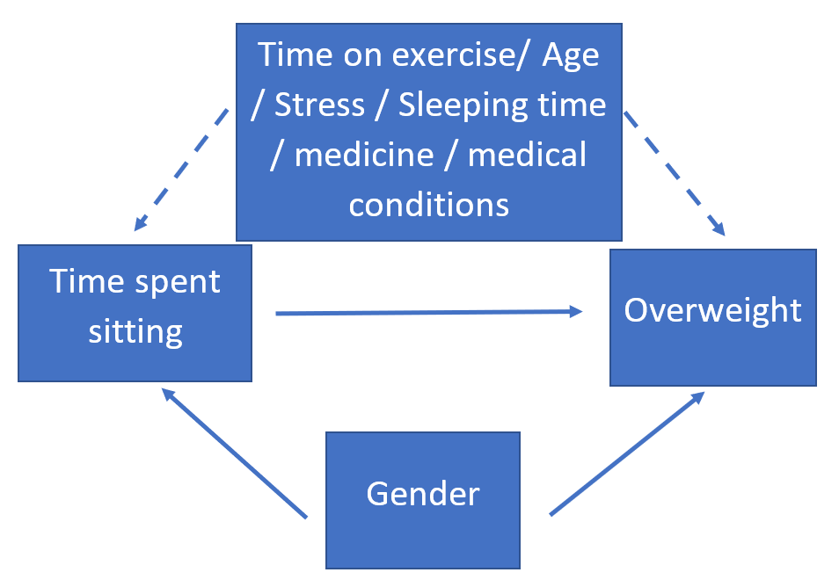

Figure 1. Directed acyclic graph. Exposure: time spent sitting; Outcome: overweight; Potential confounders: gender, time on exercise, age, stress, medicine usage, medical conditions.

|  |  |  |  |
| --- | --- | --- | --- |
| Table 1. Exposures, outcomes and confounders | | | |
|  | Variable name | Definition | Type |
| Exposure 1 | Avg time spent sitting | average hours spent sitting every day during three months prior to the survey | continuous |
| Exposure 2 | Max time spent sitting | maximum hours spent sitting during three months prior to the survey | continuous |
| Exposure 3 | prolonged sitting | Avg time spent sitting >= 8 & Max time spent sitting >=12 | binary |
| Outcome | Overweight | BMI>=25 (BMI: body mass index) | binary |
| Confounder | Age | age in years | continuous |
| Confounder | Gender | gender: Male or Female | binary |
| Confounder | time spent exercising | average hours spent exercising every week during three months prior to the survey | continuous |
| Confounder | time spent sleeping | average hours spent sleeping every day during three months prior to the survey | continuous |
| Confounder | medical conditions | common medical conditions | string |
| Confounder | medicine usage | medicine taking that may affect weight | string |
| Confounder | stress | stressed level about study/research/job | continuous integer |

**Results**

The response rate for our questionnaire is 3.47% (52/1500).

First, we did logistic regression to explore the association between high time spent sitting and overweight, adjusting for all the confounders (age, gender, stress, time spent exercising and time spent sleeping). But our results showed no statistically significant association between those with average time spent sitting and being overweight (p = 0.495). Furthermore, there was no association between maximum time spent sitting and being overweight (p = 0.1886).

However, there was a statistically significant correlation between prolong sitting exposure (Exposure 3 defined in Table 1.) and being overweight (OR=6.942, 95% CI(1.414, 34.098)). The result was found by fitting a logistic regression adjusted for all the confounders.

|  |  |  |
| --- | --- | --- |
| Table 2. Prevalence of Sitting, Obesity, and Key Potential Confounding Variables in UNC Students (n=52) | | |
| **Variable** | **Response** | **N (%) (or Mean** ± SD) |
| ***Exposure (uninterrupted prolong sitting)\**** | non-prolong sitting (average<8h, max<12h ) | 27 (51/92%) |
| prolong sitting (average=>8h, max=>12h) | 25 (48.08%) |
| ***Outcome (overweight)*** | Yes | 22(42.3%) |
| No | 30 (57.69%) |
| ***Covariate (exercise)*** | average hours spent exercising every week | 5.89 ± 3.97 |
| ***Age*** | Age in years | 26.74 ± 8.18 |
| ***Gender*** | Male | 13(25%) |
| Female | 37(71.5%) |
| **Stress** | non or moderate | 9(17.31%) |
| medium to extreme | 43(82.69%) |
| **Sleeping** | average hours spent sleeping every day | 7.00 ± 1.12 |

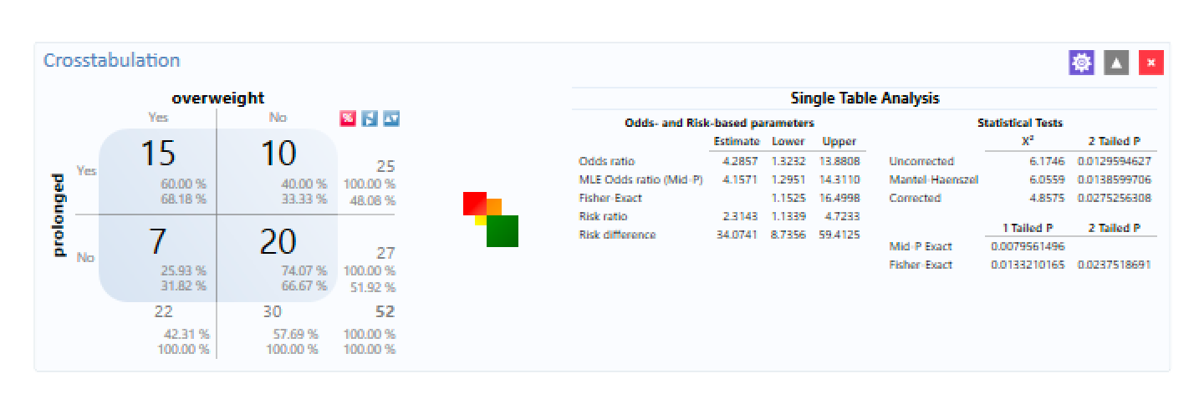Figure 2. Association between sitting time and being overweight (BMI>=25)

We then tried to determine which covariate would be the true confounder. The crude odds ratio between overweight and prolonged sitting was calculated, which is 4.2857, with 95%CI [1.3232, 13.8805]. The odds of being overweight among UNC student who sits more than 8 hours a day and has longest sat over 12 hours a day over the last three month is 4.286 times the odds of the unexposed group which has average sitting hour shorter than 8 hours and has never sat over 12 hours a day over the last three month, during 2020 spring semester. The 95%CI OR was (1.323,13.88), which does not include the null value, therefore, it is statistically significant.

Then we computed stratified OR to detect if there are potential confounders or effect measure modifiers (EMM).

|  |  |  |  |
| --- | --- | --- | --- |
| Table 3. Stratified odds ratios | | | |
| Covariate | Category | OR | Confounder / EMM |
| Gender | Female | 4.50 | Confounder or EMM |
| Male | ∞ (zero cell exists) |
| Age | < 24 years | 5.00 | EMM |
| ≥ 24 years | 4.00 |
| Stress | none or moderate | 12.00 | EMM |
| medium to extreme | 3.56 |
| Exercise | < 6 hours per week | 5.33 | EMM |
| ≥ 6 hours per week | 3.50 |
| Sleeping | < 7 hours per day | 0.86 | EMM |
| ≥ 7 hours per day | 10.80 |

Then we adjusted for the potential confounders (age, gender, time spent exercising and time spent sleeping and stress) individually to obtain the percent change for OR. After that, we will use logistic regression to adjust for all potential confounders. Finally, we will look at the fitted models and select a most reasonable one.

Adjusted OR (gender): 6.7769, 95%CI[1.6267, 28.2336]

Adjusted OR (age): 11.000,95%CI [0.8456,143.0939]

Adjusted OR (hours exercising per week): 4.5481, 95%CI [1.3294, 15.5597]

Adjusted OR (hours sleeping per day): 4.5601, 95% CI [1.2744, 16.3174]

Adjusted OR (stress): 4.0242 [1.2184, 13.2915]

Among all the adjusted OR, only the gender is considered as a significant confounder. The odds of being overweight among UNC student who sits more than 8 hours a day and has longest sat over 12 hours a day over the last three month is 6.777 times the odds of the unexposed group which has average sitting hour shorter than 8 hours and has never sat over 12 hours a day over the last three month if we control for gender, during 2020 spring semester. The 95%CI OR was (1.627, 28.234), which does not include the null value, therefore, it is statistically significant.

**Discussion**

Our results showed that there was a statistically significant association between those who engaged in prolonged sitting and being overweight. This indicates that those who are doing the most sitting do have the greatest association with being overweight. Future research could investigate the relationship between high sitting per day and continuous bouts of sitting to determine if those factors have an interaction or covariance and how that interacts with each other on metabolic health outcomes.

There were some factors in our study which could have influenced our conclusions, such as our relatively small sample size. For that reason, our conclusions could have been underpowered. Also, the fact that we used a questionnaire, rather than activity trackers such as actigraphs, could have introduced recall bias for those who sat. Some people may not properly recall how much they sit per day, because they are likely estimating rather than measuring their sitting behavior.

Furthermore, we did find that gender was a confounder, specifically as a confounding variable for being overweight. The percent change between the crude and adjusted odds ratio was 58.13% when adjusted for gender, which indicated that it was a confounding variable. Also, we had a few confounding variables which were limited in our ability to measure. For example, we had a selection question in our questionnaire for medical conditions and prescriptions, and we obtained a hugely varied list for different participants. If we could better group medications or increase the sample size, and had a medical expert on our team to help with it, we might have obtained different results.

This work indicates that people who sit for the longest part of their day are those in greatest need for health interventions, as they have the greatest association for being overweight or obese. Obesity is a mediator for a variety of negative health outcomes, and a predictor for cardiovascular disease outcomes. Therefore, interventions designed to target sitting may impact this variable, and thus decrease the cardiovascular disease risk of people who do a lot of sitting.

**Works Cited**

1. Tremblay MS, Aubert S, Barnes JD, et al. Sedentary Behavior Research Network (SBRN) - Terminology Consensus Project process and outcome. *Int J Behav Nutr Phys Act*. 2017;14(1):75. Published 2017 Jun 10. doi:10.1186/s12966-017-0525-8
2. Restaino RM, Walsh LK, Morishima T, et al. Endothelial dysfunction following prolonged sitting is mediated by a reduction in shear stress. *Am J Physiol Heart Circ Physiol*. 2016;310(5):H648–H653. doi:10.1152/ajpheart.00943.2015
3. Jia B, Nussbaum MA. Influences of continuous sitting and psychosocial stress on low back kinematics, kinetics, discomfort, and localized muscle fatigue during unsupported sitting activities. *Ergonomics*. 2018;61:1671-1684.
4. Ekelund U, Steene-Johannessen J, Brown WJ, et al. Does physical activity attenuate, or even eliminate, the detrimental association of sitting time with mortality? A harmonised meta-analysis of data from more than 1 million men and women. *Lancet*. 2016;388(10051):1302-1310. doi:10.1016/S0140-6736(16)30370-1
5. Ganasegeran, K., Al-Dubai, S.A., Qureshi, A.M. *et al.* Social and psychological factors affecting eating habits among university students in a Malaysian medical school: a cross-sectional study. *Nutr J* **11,** 48 (2012). <https://doi.org/10.1186/1475-2891-11-48>
6. Bargiota, A., Delizona, M., Tsitouras, A. *et al.* Eating habits and factors affecting food choice of adolescents living in rural areas. *Hormones* **12,** 246–253 (2013). https://doi.org/10.14310/horm.2002.1408